***STOCK PRICE PREDICTION SYSTEM***

Student name : Shubam Agarwal (169105188)

Branch : Computer Science

Reg no : 169105188



Supervisor Name : Mrs Sunita Singhal

Deparment Name : School of computation and information technology (SCIT)

University name and address : **Manipal University Jaipur,**  Dehmi Kalan, Off Jaipur-Ajmer Expressway, Jaipur, (Raj.). Rajasthan 303007.

***INTRODUCTION***

In this minor project we are trying to research the techniques used in predicting the stock market prices by using the previous years data and apply best present or a new algorithm and use it in an web application or android app.

***MOTIVATION***

To try to understand the working of the stock markets and the algorithms used now a days to predict the stock price with only the previous year data and also build a complete ready to serve platform for common users to get an idea of the stock price if the market is stable.

***PROJECT OBJECTIVE***

project objective is to understand different methods that can be used to predict the stock market price and learn about the different parameters that can be used in doing so. Existing methds are yet to be explored.

***METHODOLOGY/PLANNING OF WORK***

First we will understand how Bombay Stock Exchange works and then consult someone what are the factors that effect the market and try to get the previous year data about that and predict it for future.we will also ask few people presently in this fiels foe suggestion on the things that we can add to our platform /application that can help the users to take right decisions.

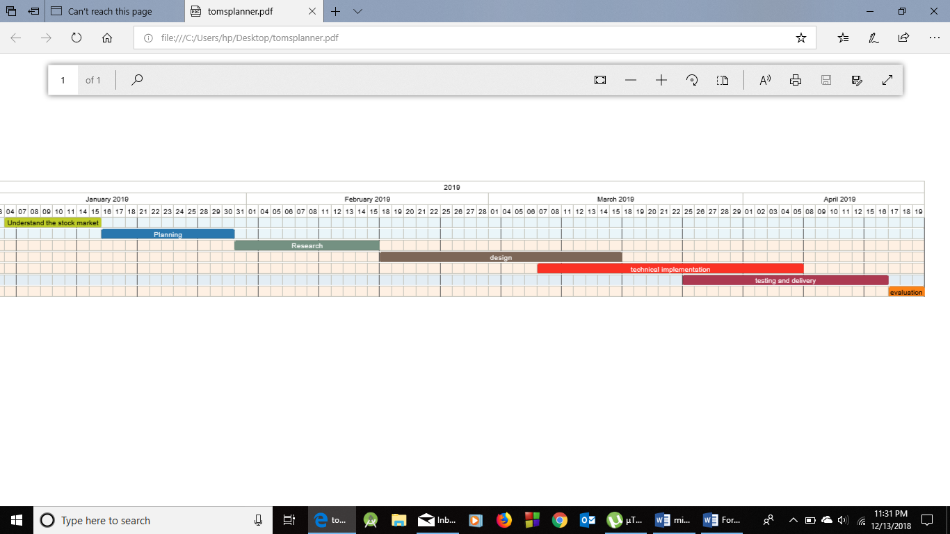

***FACILITIES REQUIRED FOR PROPOSED PROJECT***

As of our present knowledge we would only require our laptop , internet connection and mathlab software to implement prediction. But as we progress with the project we may get to know different softwares that we will take help to create the platform /application.